Ginaya Jesmer
Section 3
April 19, 2020
End of Term Assignment

COVID-19 messaging: reaching Gen Z and Gen Y

Gen Z (ages 20 to 24)

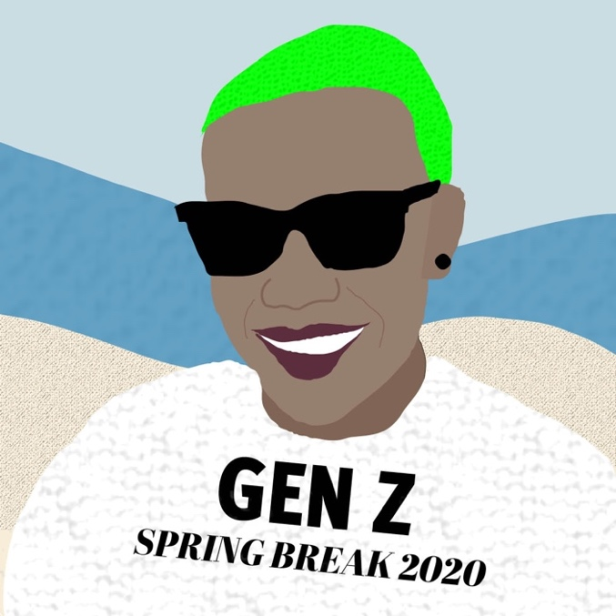
“It’s my spring break and I’ll get miss Rona if I want to!” says Jen Zed, a 22-year-old girl partying in Florida during her COVID-19 spring break.

Jen Zed is social activist with entrepreneurial aspirations. As part of the “always on” generation, Zed says she sometimes has a low attention span; therefore, quick and simple messages may work well for her.

Heading into college and soon to join the workforce, Zed lives at home with her parents (perhaps due to the financial or emotional support they provide). “Staying with the ‘rents to save rent,” Zed says.

Side note: According to Statistics Canada, Ontario has the highest national average of young people who live with their parents — likely due to the province’s high rent prices.
As of April 19, 2020: Ontario also has the nation’s second highest number of COVID-19 related deaths (Government of Canada).

The money Zed saves may go towards funding her glamorous online lifestyle — which might explain her recent trip to Florida. “Gotta get a good pic’ for the ‘gram,” Zed says, “I’m not the one at risk, and the flights were cheap. You only live once!”

Psychographic and behavioural tendencies

Keeping up with the latest trends isn’t always enough for Zed, a young Gen Z person raised on social media, the internet, and technology. She wants to be a trend-setter — which can sometimes mean breaking the rules. Zed loves YouTube, Snapchat, and Instagram. Practicing new dance moves has become second-nature to Zed since she follows the latest TikTok trends.

- Technology-dependent (grew up with technology, tech savvy)
- Always on (ready for the next thing, shorter attention span, innovators)
- Experiences (thrill-seeking, impulsive, spending income on fashion, entertainment, and socializing)

Although activists, sometimes Gen Z struggles with being unconcerned. Gen Z grew up never having experienced a time without some country at war, as well as climate change — both of which are complex problems which are not easily solved.

Zed’s generation is more inclined to consume social media through smartphones and are less committed to TV usage than older generations. Gen Z watches more YouTube and spends less time on Facebook than their Gen Y counterparts. After seeing Gen Y struggle with debt, Gen Z tries to avoid debt using debit cards instead of credit cards; therefore, understanding consequences.

News habits

- Uses YouTube and online influencers for news sources
- There is no “turning off” media

Gen Y (ages 25-29)

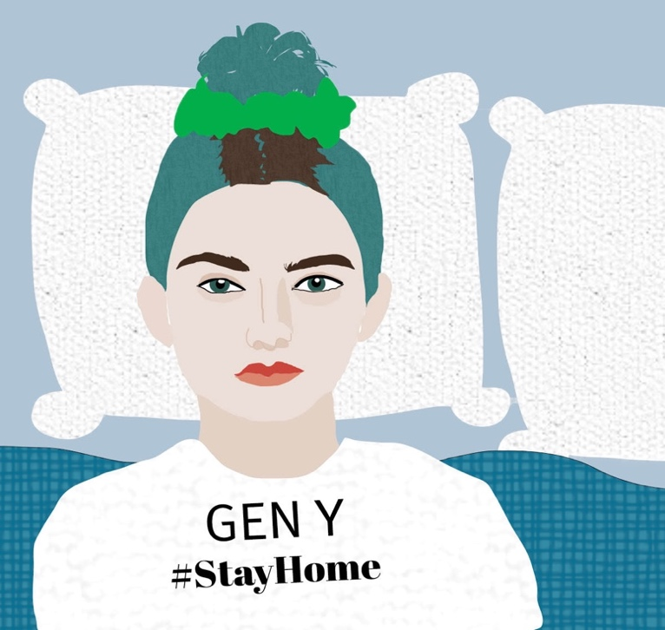
“We’re holed up in our homes with our Netflix and our anxiety, all while yelling to our parents to not hoard toilet paper,” says Jen Whye, a 27-year-old girl who just finished re-watching the entire series of The Office for the third time this month.

Many people Whye’s age are in the process of completing their education and/or are establishing their careers. Some still live at home with their parents, but some live on their own. “I’m still paying off my student debt,” Whye says, “I don’t own a house, but maybe the housing market will crash from this virus — fingers crossed.”

Whye shares a one-bedroom apartment with her dog and boyfriend. “We’re proud puppy parents,” Whye says. While many people in Whye’s generation are choosing to adopt animals, some opt for having little humans of their own.

Not everyone in Whye’s generation is dating or has a partner — COVID-19 has made some couples ask whether or not they should move in together. “I have a friend my age who was planning on moving in with their girlfriend this month but decided against it because of social distancing,” Whye says, “We’ve got to do our part to flatten the curve.”

Whye tries to follow social distancing recommendations from news outlets and health officials, but often gets overwhelmed by the amount of COVID-19 information online. “I’m taking a break from social media right now,” Whye says.

Psychographic and behavioural tendencies

Sometimes referred to online as part of the “nostalgia generation,” those in Gen Y experienced a childhood without technology but matured in a technology-dependent world.

Although curious, sometimes Gen Y struggles with mental health and information overload. Some major events which shaped Gen Y are the Great Recession and 9/11.

- Survivors (more concerned with meeting needs than filling desires, focused on safety and security)
- Tech-savvy (not as dependent on technology as Gen Z, but still well-versed)
- Ambitious, sometimes narcissistic (competitive attitude due to economic crisis)

Like Gen Z, Gen Y spends a lot of their time online — however, they may not be as dependent on it as Gen Z. Gen Y also tends to use computers more than Gen Z.

News habits

- Uses Facebook and online news outlets as news sources
- May rely on friends and family as news sources when tired of social media

Target publics

Primary publics

Our primary publics are young people between the ages of 20 to 24 who act like Jen Zed: aware, but latent. They need a reason to care — but the reason better be entertaining, quick, and come from a trusted source.

Secondary publics

Our secondary publics care but are inactive. Our secondary publics are young people between the ages of 25 to 29 who act like Jen Whye: intervening, tech savvy, and capable of creating the right messages to reach Gen Z on the correct platforms (YouTube, Instagram, etc.).

Tertiary publics
Friends and family of Gen Y (particularly older generations) may help moderate news information for people like Jen Zed who become burnt out from too much media; therefore, it may be helpful to relay messages to older generations saying “look out for loved ones” (including their Gen Z and Gen Y children) and encourage them to keep friends and family informed and up-to-date with credible information regarding COVID-19.

Tertiary publics may also include social media influencers, including YouTubers and vloggers; these publics may be able to reach both Gen Z and Gen Y.

Messages

Gen Z
- If you ignore health recommendations and continue to gather in large crowds, it will cost you:
  - Your loved ones: such as parents, grandparents, and other at-risk friends and family who may become ill with COVID-19
  - Your experiences: the less we listen to the recommended guidelines (such as social distancing, handwashing, etc.) the more events will be cancelled and the longer the virus’s effects will last
  - Your future: COVID-19 will have lasting effects on the economy and our communities if we do not act now
- You don’t live twice
  - Nobody is immune to this virus — not your friends, not your favourite YouTubers, and not you
  - In order to live life to the fullest, you need a life to live
  - By staying home, you are protecting yourself and the people you care about
- You can make an impact
  - It’s not often you get the opportunity to be a hero by staying inside
  - This event will not be easily forgotten — what actions would you like to be remembered by?
  - Make a difference by staying home
“It will cost you” is directed towards our primary publics (Gen Z) who are not taking COVID-19 seriously. The tone of this message is direct and firm. The sub-messages remind Gen Z about the things they care about: their loved ones, experiences, and future; therefore, they may be more motivated to listen.

The second Gen Z message takes a more comedic approach (still highlighting the same sub-messages) might be the message, “you don’t live twice.” This is a reference to Gen Z people who think they are living life to the fullest by going out and rebelling against social distancing rules.

The third message “you can make an impact” is the simplest message. Stay home and make an impact.

Gen Y
- We are in this together
  - You are not alone
  - Reach out to friends and family if you’re struggling
  - Your feelings are valid: we understand this is a difficult time
- You can make an impact:
  - by following and staying informed about the latest COVID-19 guidelines and recommendations
  - by looking out for younger generations
  - by talking to others about why it’s important to stay at home (directing them to credible sources)
- Your friends and family need you
  - Check up on your loved ones: see how they are feeling
  - Check in with yourself: how are you feeling?
  - Offer kindness and support: nobody is immune to feeling the impacts of this virus

“You are not alone” is directed towards our secondary publics (Gen Y) who are feeling the impacts of COVID-19. While they may be active in following recommended health guide lines, they may not be as active in maintaining their mental health. The tone of this message is empathetic and encouraging; therefore, uplifting spirits and encouraging Gen Y to “make an impact” (on Gen Z).

This secondary message also works for our tertiary publics.

Communication channels

YouTube

It’s not just funny videos — it’s also Jen Zed’s favourite way to digest media. If we want to reach Gen Z, we will want to be on YouTube. Many YouTubers are feeling the impacts of COVID-19 (they or their loved ones may be at-risk or may have lost jobs) and are already open to sharing messages about COVID-19 — so let’s make sure they’re sharing the right ones; therefore, we will also direct our messages towards YouTubers. We can encourage YouTubers to provide links to credible sources and engage directly with their followers through their various social media platforms.

Facebook

Gen Z may argue “Facebook is for old people,” but this is the platform Gen Y grew up with. We don’t want to demoralize Gen Y; therefore, we will keep our messages on Facebook uplifting and lighthearted. We can encourage Facebook to provide links to credible sources.

Instagram

On Instagram, a platform most Gen Z and Gen Y use, we can speak with influencers about sharing our key messages on their Instagram Stories and feed. Specifically, we could take advantage of the comedic key message, “you don’t live twice” and turn this into a hashtag (#YouDontLiveTwice) in order to unify our message between a variety of influencers.

Snapchat

We can email Snapchat and see if they would be willing to create a COVID-19 themed filter which links to credible news sources (such as WHO and Government of Canada) and/or explains some of the best healthcare practices (handwashing, social distancing, etc.).

Action and communications

- Partnering with YouTubers
Every day throughout May we will contact three YouTubers and ask them to share a message about COVID-19. Ideas for videos include:
- Making blanket forts (to share the message: home can be fun)
- Personal stories about friends/family affected by COVID-19 (to share the message: nobody is immune to the virus)
- Inspirational speeches (to share the message: you can make a difference)
We will measure our success by comparing the total number of YouTubers we approach to the total number of videos they create mentioning COVID-19 during the month of May. We will aim for a 50 per cent of the YouTubers we approach to post a post with our message.

- An online Facebook event
We will create an online campaign throughout May featuring a series of livestreamed social-distancing friendly events. Ideas for events include:
  - Facebook live concerts with popular musicians
  - Facebook live cooking with a professional chef
  - Facebook live with motivational speakers/therapists
We will measure our success by the number of people who say they are “Going” on the Facebook event. We are aiming for 20,000 attendees.
- Partnering with Instagram influencers
Every day throughout May we will contact three Instagram influencers and ask them to share a message about COVID-19. The message is “You don’t live twice. Stay home, stay safe.” There will be two call-to-actions including using the hashtag #YouDontLiveTwice and tagging three friends to do the same.
We will measure our success by comparing the total number of influencers we approach to the total number of videos under the hashtag #YouDontLiveTwice during the month of May. We will aim for twice as many videos used under the hashtag #YouDontLiveTwice as the number of influencers we approach.
- Snapchat
We will a goofy snapchat filter which uses the hashtag #YouDontLiveTwice which features the phrase “Stay home, stay safe.”
We will measure our success by tracking the number of times the filter was used. We are aiming for the filter to be used 5,000 times during the month of May.
- TikTok
We will create a song about social distancing and post it to TikTok. Any use of the song will link to credible sources about the latest COVID-19 news.
We will measure our success by tracking the number of times the voice track was used throughout the month of May. We aim for the song to be used 20,000 times.

